*TalkBox* Design Document

**Scope and Maintainability**

This project has three main applications: *Talkbox Configurator*, *Talkbox Simulator*, and *TBC Log*. The configuration application relies on multiple classes for its functionality. These are talked about in detail in the **Testing Document.** Throughout this development process we have aimed to make these classes as modular as possible, relying heavily on encapsulation and abstraction. Thus, the UML diagrams show the heavy reliance on external components with their own core functionalities (e.g., ButtonConfiguration and adding their features like images and sounds). Thus, future tweaks and development could go on without having to worry about the internal details of other classes. For instance, if we were to add a “text-to-speech” feature, we simply would have to add that to the GUI. No changes to any other core classes would be needed. As well, all the classes are all documented (in the javadoc folder), so the codebase is highly maintainable.

**The Sequence Diagram**

This sequence diagram represents a scenario of a user using the *Talkbox Configurator*. The operations include creating a configuration, loading a configuration, recording in the main menu, adding images, emojis, and sounds to buttons, and playing those sounds.

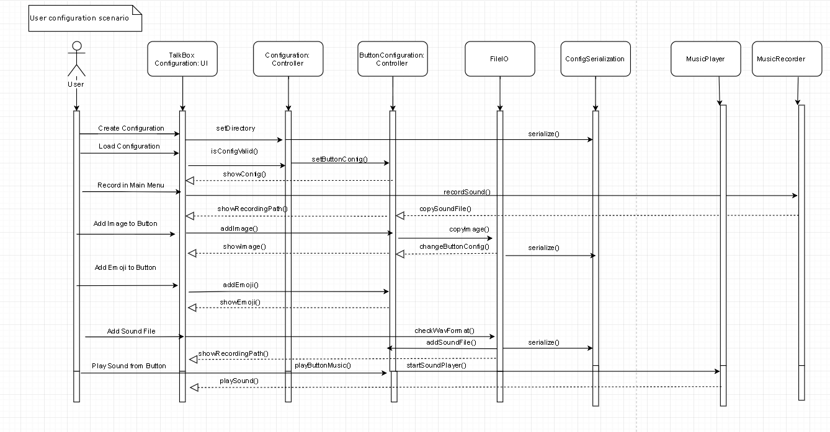

**The UML Diagrams**

These two diagrams represent the first two apps and their relationships with other core classes. The last UML diagram represents the TBC Log GUI and how it relies on a controller class as well as the Swing components.

***UML Diagram #1***

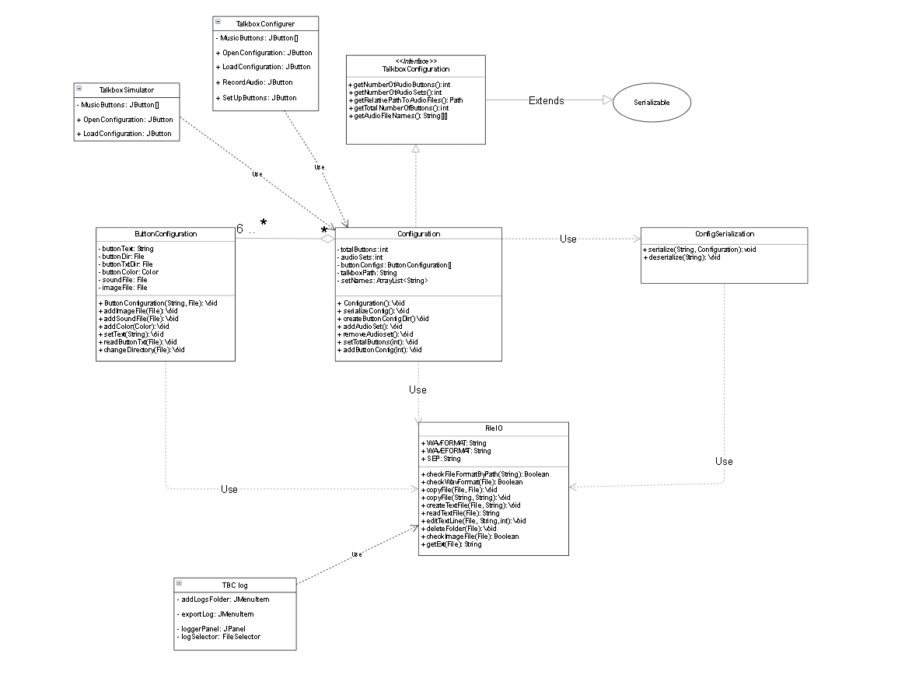

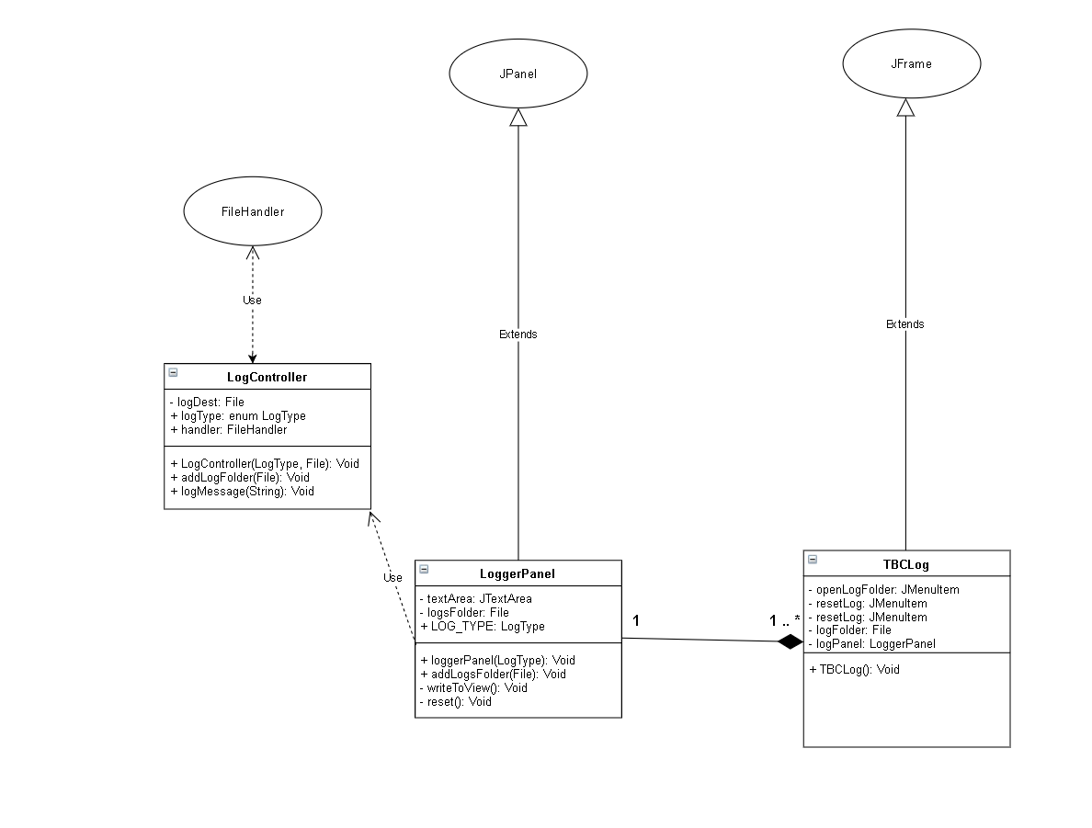  
  
***UML Diagram #2***